FIRST TERMINAL EXAMINATION SEPTEMBER - 2019
Marks obtained:

Total:
60
Name: ___________________________
Grade: II Section___
Subject: EVS
Date: 27.09.2019
Time: 3 Hours

I. Choose the correct answer. (10x1=10)
1. Food contains ________________.
a) nutrients
b) nutents
c) nrituent
2. Cereals, pulses and nuts are the examples of ___________________.
a) energy giving food
b) protection giving food
c) body building food
3. _____________ helps to build our bones strong.
a) Carrot b) oil c) milk

4. Which one is not used to build temporary house?
a) Straw b) bricks c) mud
5. A _________________ house is built above the ground in an area where it rains a lot.
a) bungalow b) igloo c) stilt
6. Choose the odd one.
a) mop b) broom c) toilet brush
7. We should keep our water__________.
a) mess b) clean c) dirty
8. These houses float on water_____________.
a) house boat b) stilt c) bungalow
9. ___________ is an example of underground vegetable.
a) lady’s finger b) potato c) drumstick
10. An _____________ is a collection of several houses built one on top of the other.
a) hut c) apartment c) bungalow
II. Fill in the blanks with suitable answer. (5x1=5)
11. We should _________ the water to kill germs.
12. ___________ food is not good for us.
13. We should not _________________ food.
14. _______________ water is an artificial source of water.
15. ______________ is the main source of water.
III. State whether the sentences are true or false. (5x1=5)
16. Babies eat the same food as a 30years old.
17. Eggs, milk and meat are the examples of body building food.
18. An igloo is a house made of huge logs of wood.
19. House boats float on water.
20. Drinking dirty water makes the people and animals sick.
IV. Match the following. (5x1=5)
21. Dirty water pizza
22. Lake temporary house
23. Junk food germs
24. Healthy food natural water
25. Straw and mud vegetables
V. Answer the following. (5x3=15)
26. Why should we have doors and windows in a house?
______________________________________________________________________________________________________________________________________________________________________________________________________
27. List three food groups.
______________________________________________________________________________________________________________________________________________________________________________________________________
28. Name any 3 things used to build the temporary house.
______________________________________________________________________________________________________________________________________________________________________________________________________
29. Write any 3 natural sources of water.
______________________________________________________________________________________________________________________________________________________________________________________________________
30. Mention some uses of water.
______________________________________________________________________________________________________________________________________________________________________________________________________
VI. Draw a houseboat and colour it. (1x4=4)

V. Draw the uses of water (any five) (1x5=5)
V. Draw the uses of water (any five). (1x5=5)
31.
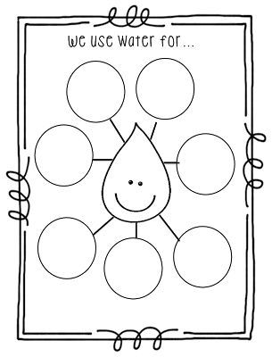

VII. Give two examples for the following. (3x2=6)
32. Milk products
_______________, _______________
33. Junk food
_______________, _______________
34. Healthy food
_______________, _______________

VIII. Answer in a paragraph. (1x5=5)
34. Write any three ways in which water gets polluted?
_________________________________________________________________
_________________________________________________________________
_________________________________________________________________
_________________________________________________________________
_________________________________________________________________
********************************

